Software Requirements and Design Document

For

Fantasy Football

Version 1.0

Authors:
Miles G
Tanner S
Amadou L
Edward P

Overview (5 points)
Ultimate Fantasy Football is a web app built to make fantasy football more hands-on and strategic throughout the week, rather than just checking scores on Sundays. Developed with React/TypeScript on the front end and a Python backend, the platform puts players in the role of a head coach. Users can pick specific coach traits at the start of the season (like a run-heavy scheme for running back multipliers), build team chemistry bonuses by pairing up former college teammates or current NFL teammates, and run daily trivia minigames to prep for matchups. To keep things interactive, teams also manage their home stadium atmosphere and training facilities to keep players fresh and prevent simulated weekly atrophy.
From a technical standpoint, the biggest challenge is pulling near-live game stats while staying under Tank01’s free tier of 1,000 API calls a month. To solve this, the backend separates static data from live data. Permanent player details like college alma mater are loaded into a PostgreSQL database just once before the season starts, and team rosters are updated once a week on Saturday mornings to catch any trades or cuts. Because player chemistry and coach boosts are calculated locally in our own database with zero external calls, practically our entire API budget is saved for a scheduled caching service that pulls live box scores every 5 to 10 minutes only while games are being played.

Functional Requirements (10 points)

Accounts and Roles
1. The system will allow a visitor to register an account with a unique email address, a unique username, and a password. (High)
2. The system will allow a registered user to log in and log out. (High)
3. The system will support two roles: User and League Manager. (High)
4. The system will grant League Managers access to all User features plus the League Management View. (High)
5. The system will automatically assign the League Manager role to the user who creates a league, for that league only. (High)
6. The system will restrict League Management functions so that Users who are not the manager of a league cannot access them. (High)
2.2 League Management (League Manager)
7. The system will allow a League Manager to create a league with a name and a maximum number of teams (minimum 4, maximum 16). (High)
8. The system shall allow a League Manager to invite users to the league through a shareable invite code or link. (High)
9. The system shall prevent users from joining a league that has reached its maximum team count. (High)
2.3 Roster Management
10. The system shall allow a User to view their roster, including each player's position, real-life team, and current status. (High)
11. The system shall allow a User to set their starting lineup (e.g., 1 QB, 2 RB, 2 WR, 1 TE, 1 FLEX, 1 K, 1 DEF) and place the remaining players on the bench. (High)
12. The system shall lock a player in a User's lineup once that player's real-life game begins. (High)
13. The system shall reject a lineup that violates the required position slots and tell the User which slot is invalid. (High)
14. The system shall allow a User to add a free agent to their roster and drop a rostered player in the same transaction. (High)
15. The system shall display a Free Agency View listing all unrostered players, filterable by position and searchable by name. (High)
16. The system shall prevent a User from exceeding the maximum roster size defined for the league. (High)
2.4 Scoring, Scoreboard, and History
17. The system shall calculate each player's fantasy points from real-life statistics using the league's scoring rules. (High)
18. The system shall apply active coach-trait multipliers, chemistry bonuses, and atrophy penalties to a player's base fantasy points to produce the final score. (High)
19. The system shall display the breakdown of each player's final score (base points, coach multiplier, chemistry bonus, atrophy penalty, minigame bonus). (High)
20. The system shall display a Weekly Scoreboard showing every matchup in the league with live-updating scores during games. (High)
21. The system shall determine each matchup's winner at the end of the week and update league standings (wins, losses, ties, total points). (High)
22. The system shall allow a User to view any previous week's lineup, player scores, and matchup result. (Medium)
23. The system shall display an Upcoming Schedule of the User's future fantasy matchups and relevant real-life games. (Medium)
2.5 Coach Traits
24. The system shall require each User to select one coach trait at the start of the season (e.g., Run-Focused, Pass-Focused, Defensive-Minded). (High)
25. The system shall apply the selected trait's multiplier to the fantasy points of the affected player positions (e.g., Run-Focused increases RB points by a fixed percentage). (High)
26. The system shall not allow a User to change their coach trait after the season begins. (Medium)
27. The system shall cap the total combined effect of multipliers and bonuses so that base real-life performance remains the dominant factor in a player's score. (High) Rationale: the proposal's risk section states that big real-life performances should not be minimized by the added features. A cap is a concrete way to enforce that.
2.6 Chemistry and Atrophy
28. The system shall award a chemistry bonus to a player when another player on the same fantasy roster currently plays for the same real-life NFL team. (Medium)
29. The system shall award a chemistry bonus to a player when another player on the same fantasy roster attended the same college. (Medium)
30. The system shall display which chemistry links are active for each roster player. (Medium)
31. The system shall apply an atrophy penalty to each rostered player's score that increases each week of the season. (Medium)
32. The system shall reduce or eliminate a player's atrophy penalty according to the current level of the User's Training Facility. (Medium)
2.7 Daily Minigame
33. The system shall present each User with one trivia minigame per calendar day. (Medium)
34. The system shall record a User's minigame result and limit each User to one attempt per day. (Medium)
35. The system shall convert a User's minigame results during a week into a bonus multiplier applied to that week's score. (Medium)
36. The system shall reset the accumulated minigame bonus at the start of each new fantasy week. (Medium)
2.8 Home Stadium and Training Facility
37. The system shall provide each User with a Home Stadium page displaying stadium condition, fan attendance, and crowd noise level. (Low)
38. The system shall allow a User to spend in-game currency to maintain the stadium and keep it in good standing. (Low)
39. The system shall change fan attendance and crowd noise based on stadium condition and team performance. (Low)
40. The system shall apply a home-field bonus to a User's score in weeks when they are the home team, scaled by crowd noise level. (Low)
41. The system shall allow a User to upgrade their Training Facility through defined levels using in-game currency. (Low)
42. The system shall award in-game currency to Users based on weekly results and minigame performance. (Low)
2.9 Data and Statistics
43. The system shall retrieve player, schedule, and live game statistics from the Tank01 NFL API. (High)
44. The system shall update live statistics during games at least every 5 minutes, matching the API's data freshness. (High)
45. The system shall serve statistics to Users from a cache rather than calling the external API for each User request. (High)
46. The system shall display the time of the last successful data update on the scoreboard. (Medium)
47. The system shall notify Users that data may be delayed if the external API is unavailable, and continue to show the last cached data. (Medium)
NON-FUNCTIONAL REQUIREMENTS

Non-functional Requirements (10 points)
1. [Performance] The system shall load any page in under 3 seconds under normal conditions for cached content.
2. [Performance] The system shall reflect a lineup or roster change in the interface within 2 seconds of submission.
3. [Performance] The system shall support at least 100 concurrent users without noticeable degradation. Rationale: appropriate scale for class demonstration and testing.
4. [API Usage] The system shall keep external API usage within the Tank01 free tier limit of 1,000 calls per month during development and demonstration, by using caching and scheduled refreshes. Rationale: this is the main risk identified in the proposal.
5. [API Usage] The system shall poll the external API only while at least one NFL game is in progress, and use a much lower refresh frequency otherwise.
6. [Security] The system shall store passwords only as salted hashes, never in plaintext.
7. [Security] The system shall transmit all data over HTTPS.
8. [Security] The system shall enforce role-based authorization on the server side for every request, not just in the interface.
9. [Security] The system shall protect against common web vulnerabilities including SQL injection, cross-site scripting, and cross-site request forgery.
10. [Security] The system shall keep API keys out of client-side code and the source repository.
11. [Reliability] The system shall remain available with at least 99% uptime during scheduled NFL game windows.
12. [Reliability] The system shall not lose committed user data (rosters, lineups, scores) in the event of a server restart.
13. [Accuracy] The system shall calculate scores deterministically, so the same inputs always produce the same final score.
14. [Accuracy] The system shall be able to recompute any week's scores from stored statistics, to correct for stat corrections issued after games.
15. [Usability] The system shall allow a new user to register, join a league, and set a lineup without external instructions.
16. [Usability] The system shall be fully usable on the current versions of Chrome, Firefox, Safari, and Edge.
17. [Usability] The system shall provide a responsive layout that is usable on both desktop and mobile screen sizes.
18. [Maintainability] The system shall keep all tunable values (multiplier sizes, chemistry bonuses, atrophy rates, roster sizes) in configuration rather than hard-coded, so they can be adjusted without code changes. Rationale: balancing these values is a stated risk.
19. [Maintainability] The system shall separate the frontend (TypeScript/React) from the backend (Python) through a documented REST/JSON API.
20. [Maintainability] The system shall be version-controlled and have automated tests covering the scoring calculation logic.
21. [Scalability] The system shall use a database schema and cache design that can be extended to more leagues and a paid API tier without redesign.
22. [Data Integrity] The system shall process simultaneous roster transactions (e.g., two teams claiming the same free agent) so that only one succeeds and the other is notified.
23. [Privacy] The system shall collect only the personal data needed for accounts (email, username) and not share it with third parties.

Use Case Diagram (10 points)
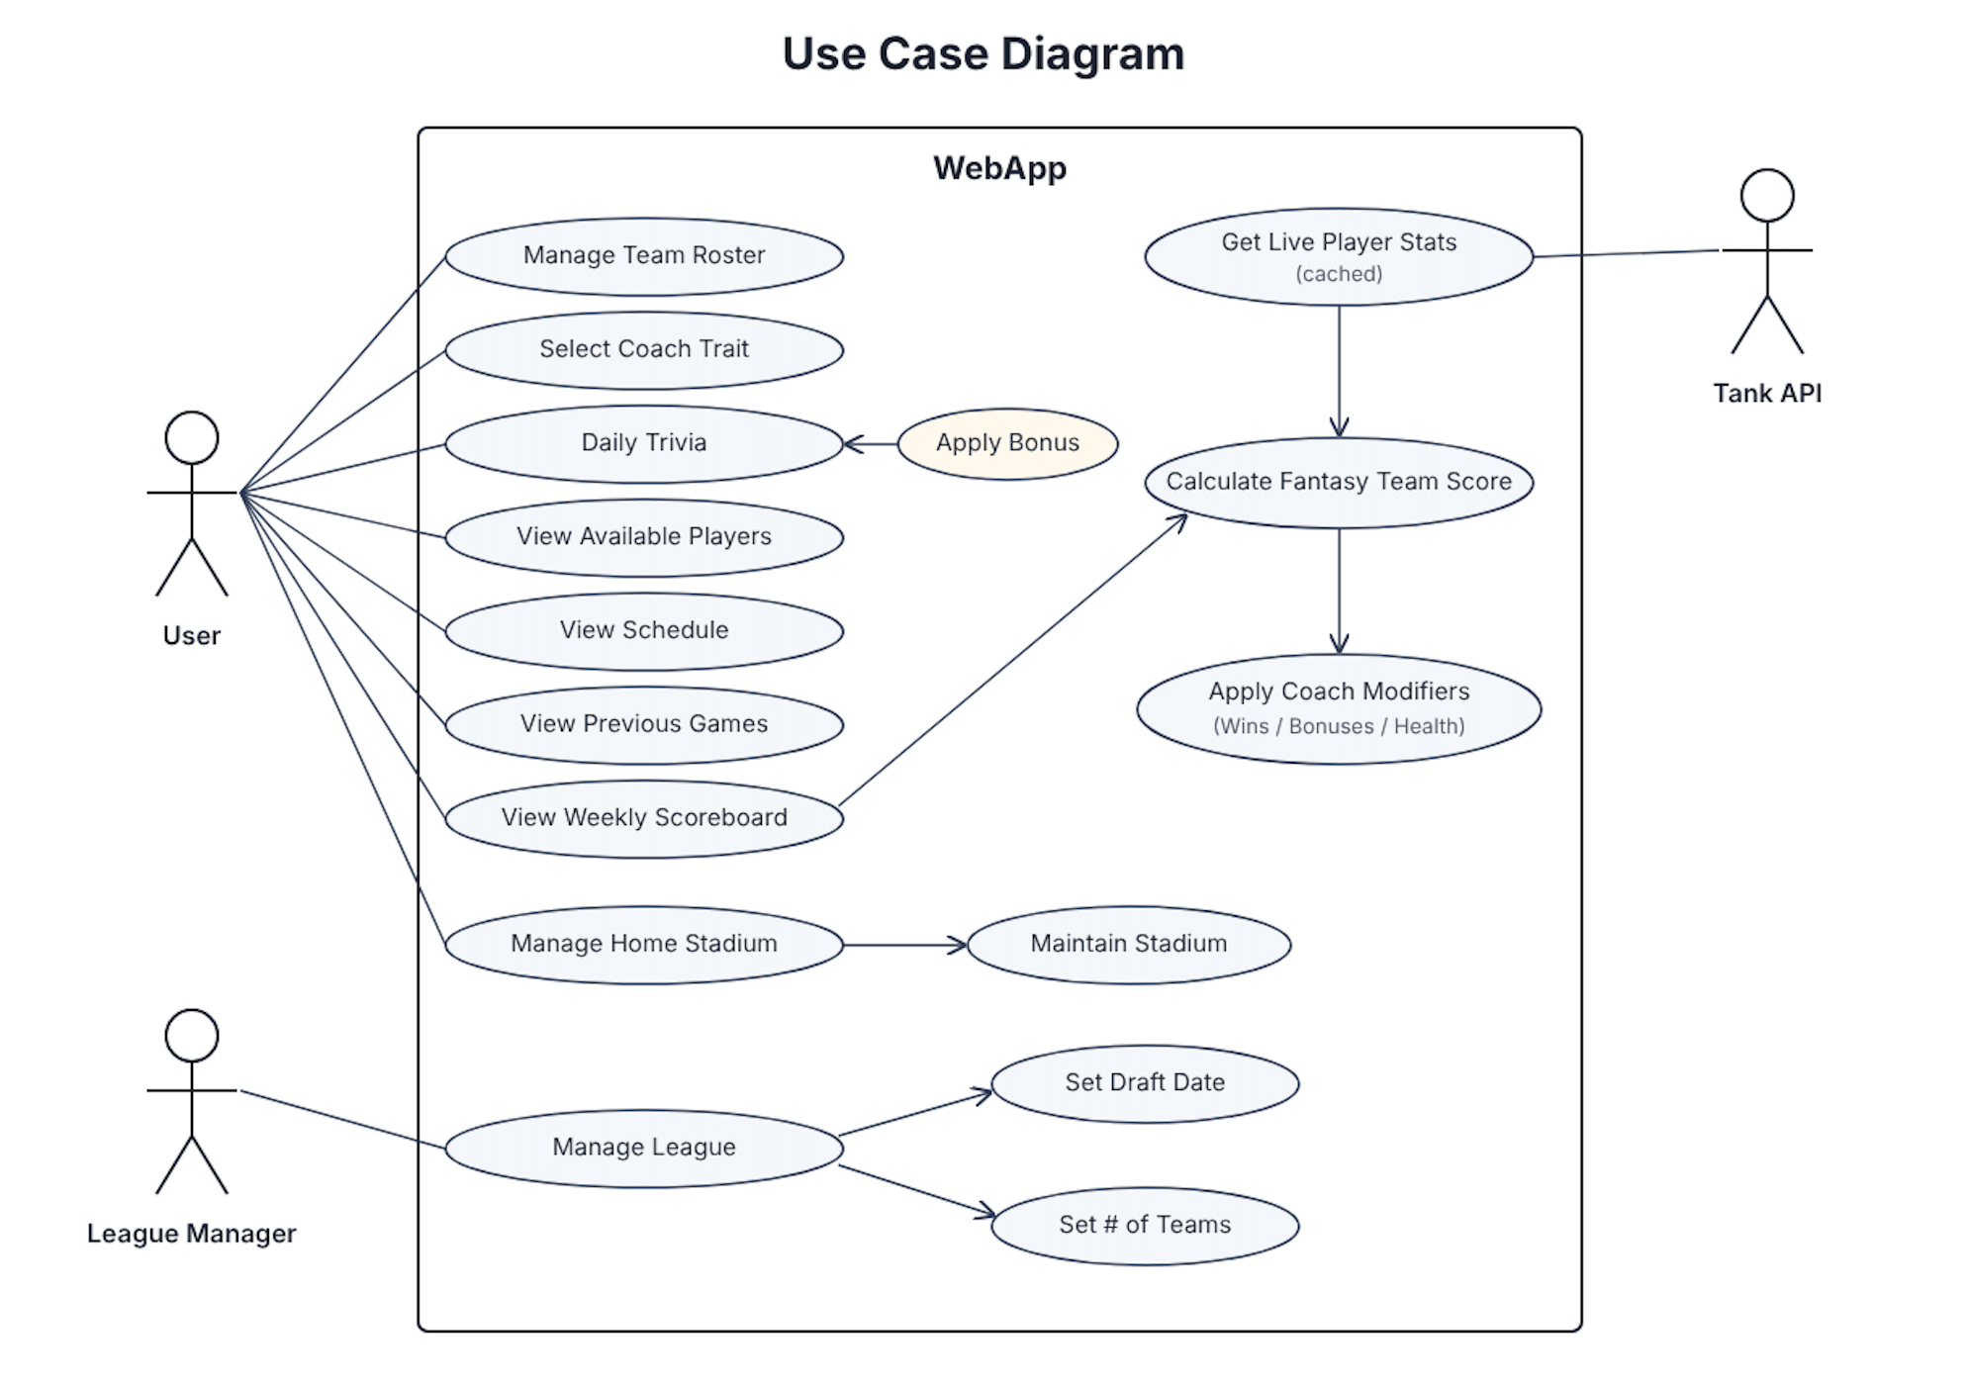

Class Diagram and/or Sequence Diagrams (15 points)

SINCE THE CLASS DIAGRAM IS RATHER LARGE, IT IS INDEPENDENTLY SITTING IN GITHUB AS CLASSDIAGRAM.PDF
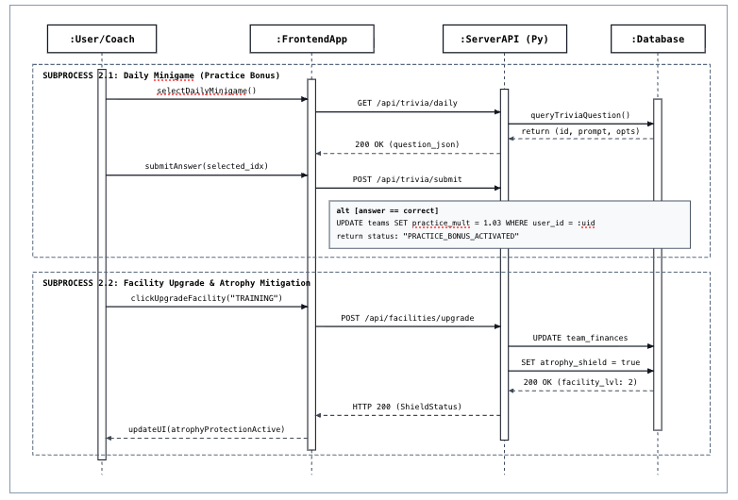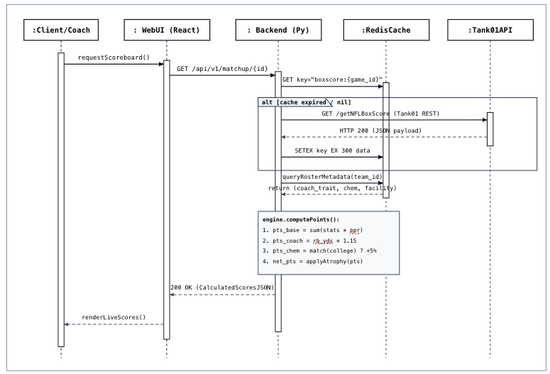. 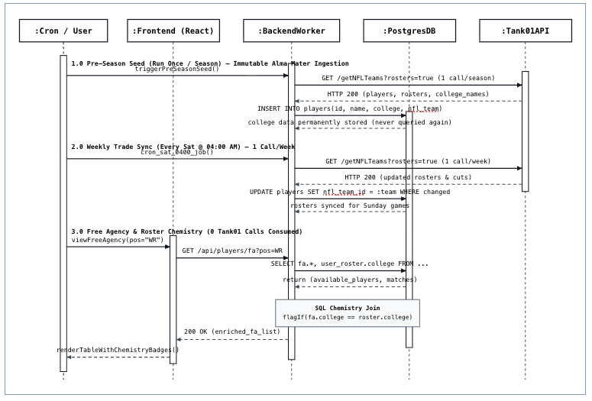

Operating Environment (5 points)
Ultimate Fantasy Football runs as a standard web application, meaning users can access it from any normal desktop, laptop, tablet, or phone with an internet connection. It works across major operating systems like macOS, Windows, iOS, and Android using everyday web browsers such as Chrome, Safari, Edge, or Firefox, without requiring any downloads or special hardware.
On the hosting side, the system runs on a modest Linux cloud server or container using 1 virtual CPU and 1 to 2 GB of RAM. The software itself is built with a React and TypeScript front end, a Python backend, and uses PostgreSQL for its main database alongside Redis to temporarily cache live game scores. It pulls real-time NFL stats from the Tank01 API over regular HTTPS. Because it relies only on basic web traffic, the app coexists naturally with campus Wi-Fi, home networks, and standard firewalls without running into port conflicts or needing custom network configurations.

Assumptions and Dependencies (5 points)
Assumptions:
- Tank01 API stays free and keeps its 1,000 calls-per-month limit. If they lower the cap or charge money, our updates break.
- College names in the API are consistent and spelled right so our chemistry system works without manual fixing.
- Live stats actually update within 5 to 10 minutes so game-day scores don't feel delayed.
- Free hosting allows background tasks (cron jobs) to run our Saturday roster sync and game-day polling without falling asleep.
- The app only needs to handle small class demo sizes (1 league, 2-4 teams)
- We can use mock or saved game data to demo the scoring system during class when no live NFL games are on.
- Multipliers (coach traits, chemistry, stadium boosts) won't break the game or completely override real player performances.
Dependencies:
- RapidAPI: We need their service up to route our Tank01 requests.
- Trivia questions: We may need a pre-made list of football questions for the daily minigame.

